INDEX
S.No | Date | Experiment | Page No | Signature
1 |  | IMAGE CONVERSIONS (COLOR IMAGE TO GRAY SCALE IMAGE)
2 |  | IMAGE CONVERSIONS (GRAY SCALE IMAGE TO BINARY)
3 |  | VISUALISATION OF COLOR COMPONENTS IN COLOR IMAGES
4 |  | CONTRAST ENHANCEMENT IN IMAGES
5 |  | NOISE ATTACK IN IMAGES (GAUSSIAN NOISE, POISSON NOISE)
6 |  | NOISE ATTACK IN IMAGES SALT AND PEPPER NOISE, SPECKLE NOISE
7 |  | DISTANCE MEASURES BETWEEN TWO PIXELS IN IMAGES
8 |  | GRAY LEVEL TRANSFORMATION-IMAGE NEGATIVE
9 |  | BLURRING AND DEBLURRING
10 |  | HISTOGRAM EQUALISATION
11 |  | NOISE FILTERING USING WIENER FILTER
12 |  | NOISE FILTERING USING MEDIAN FILTER
13 |  | WAVELET SUBBAND CODING
14 |  | IMAGE SMOOTHENING
15 |  | MORPHOLOGICAL PROCESSING  (DILATION AND EROSION)
16 |  | MORPHOLOGICAL PROCESSING  (OPENING AND CLOSING)

EXP. 1
IMAGE CONVERSIONS
(COLOR IMAGE TO GRAY SCALE IMAGE)

Aim:

To display the Gray scale images from color images using MATLAB software

Apparatus Required

Personal Computer
MATLAB software

Program

A = imread('penguins.jpg');
subplot(1,2,1);
imshow(A);
title('Colour Image');
B = rgb2Gray(A);
subplot(1,2,2);
imshow(B);
title('Gray Scale Image');

Procedure

(i) Type the MATLAB coding in Script Page of program window
(ii) Save and Run the coding
(iii) Display, Save and Present the results for verification

Output
Color Image to Gray scale Image
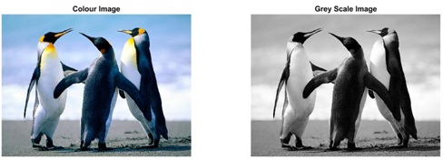

Results
Thus the gray scale image is obtained from color image using MATLAB software.

EXP. 2
IMAGE CONVERSIONS
(GRAY SCALE IMAGE TO BINARY)

Aim:

To display the Binary images from Gray scale images using MATLAB software

Apparatus Required

Personal Computer
MATLAB software

Program
A = imread('Flower.jpg');
subplot(1,3,1);
imshow(A);
title('Colour Image');
B = rgb2Gray(A);
subplot(1,3,2);
imshow(B);
title('Gray Scale Image');
C = im2bw(A);
subplot(1,3,3);
imshow(C);
title('Binay Image');

Procedure
(i) Type the MATLAB coding in Script Page of program window
(ii) Save and Run the coding
(iii) Display, Save and Present the results for verification
Output
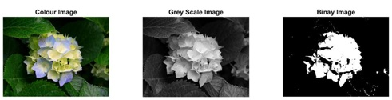

Results

Thus the binary image is obtained from Gray scale image using MATLAB software.
EXP. 3
VISUALISATION OF COLOR COMPONENTS IN COLOR IMAGES

Aim:

To visualise color components from color images using MATLAB software

Apparatus Required

Personal Computer
MATLAB software

Program

A = imread('Desert.jpg');
subplot(2,2,1);
imagesc(A);
title('Colour Image');
subplot(2,2,2);
imagesc(A(:,:,1));
title('Red');
subplot(2,2,3);
imagesc(A(:,:,2));
title('Green');
subplot(2,2,4);
imagesc(A(:,:,3));
title('Blue');

Procedure

(i) Type the MATLAB coding in Script Page of program window
(ii) Save and Run the coding
(iii) Display, Save and Present the results for verification

Output

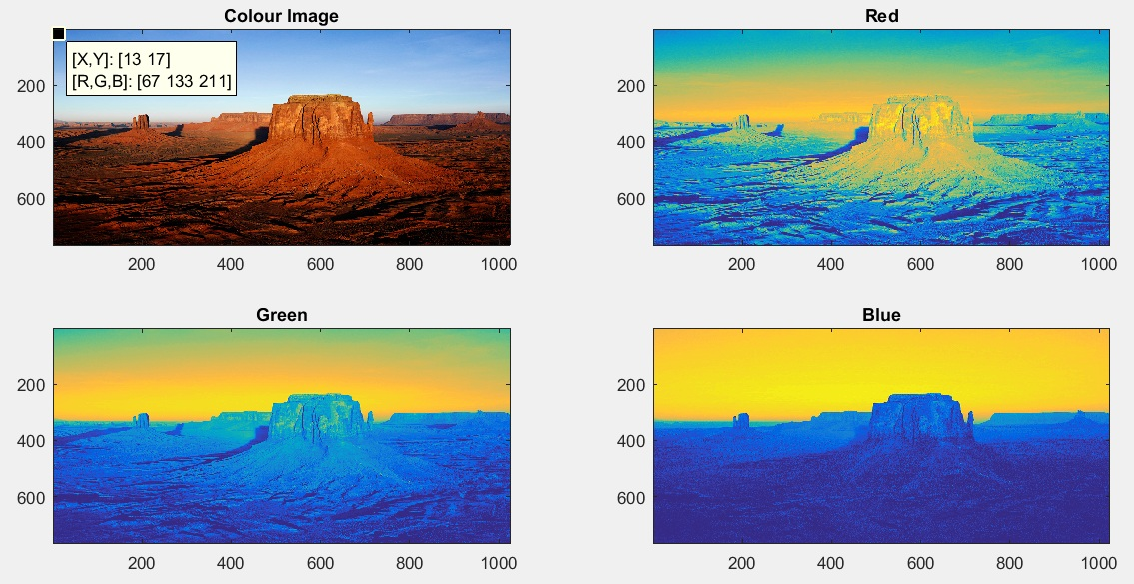

Results

Thus the three major colour components from color image is obtained using MATLAB software.

EXP. 4
CONTRAST ENHANCEMENT IN IMAGES

Aim:

To Enhance the contrast of Gray scale image and color images using MATLAB software

Apparatus Required

Personal Computer
MATLAB software

Program

(iii) Display, Save and Present the results for verification

A = imread('Tulips.jpg');
subplot(2,2,1);
imshow(A);
title('Input-Color image');
subplot(2,2,2);
B=imadjust(A,[.3 .7],[]);
imshow(B);
title('Contrast Enhanced Color image');
C = rgb2gray(A);
subplot(2,2,3);
imshow(C);
title('Input-Gray Scale Image');
subplot(2,2,4);
D=imadjust(C,[.3 .7],[]);
imshow(C);
title('Contrast Enhanced Gray scale Image');

Procedure

(i) Type the MATLAB coding in Script Page of program window
(ii) Save and Run the coding

Output

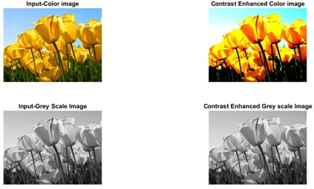

Results

Thus the color enhancement technique is applied to images and corresponding results were obtained using MATLAB software.

EXP. 5
NOISE ATTACK IN IMAGES
(GAUSSIAN NOISE, POISSON NOISE)

Aim:

To see the effects of noise in images using MATLAB software

Apparatus Required

Personal Computer
MATLAB software

Program

- Gaussian noise

A = imread('bird.jpg');
subplot(1,3,1);
imshow(A);
title('Colour Image');
B=imnoise(A,'gaussian',0,0.01);
subplot(1,3,2);
imshow(B);
title('Gaussian noise affected Image');

- Poisson noise

C=imnoise(A,'poisson');
subplot(1,3,3);
imshow(C);
title('Poisson noise affected Image');

Procedure

(i) Type the MATLAB coding in Script Page of program window
(ii) Save and Run the coding
(iii) Display, Save and Present the results for verification

Output

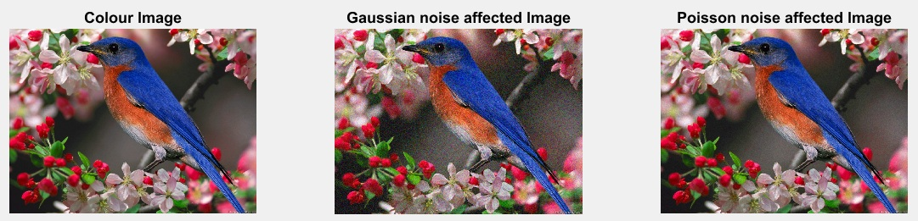

Results

Thus the effects of Gaussian and Poisson noise are studied using MATLAB software.

EXP. 6
NOISE ATTACK IN IMAGES
(SALT AND PEPPER NOISE, SPECKLE NOISE)

Aim:

To see the effects of noise in images using MATLAB software

Program

- Salt and pepper noise

A = imread('butterfly.jpeg');
subplot(1,3,1);
imshow(A);
title('Colour Image');
B=imnoise(A,'salt & pepper',0.02);
subplot(1,3,2);
imshow(B);
title('salt & pepper noise affected Image');

- Speckle noise

C=imnoise(A,'speckle',0.04);
subplot(1,3,3);
imshow(C);
title('speckle noise affected Image');

Procedure

(i) Type the MATLAB coding in Script Page of program window
(ii) Save and Run the coding
(iii) Display, Save and Present the results for verification

Output

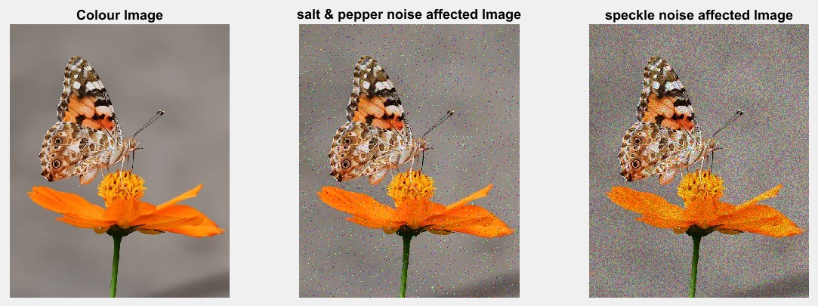

Results

Thus the effects of salt and pepper noise and speckle noise are studied using MATLAB software.

EXP. 7
DISTANCE MEASURES BETWEEN TWO PIXELS IN IMAGES

Aim:

To measure the Euclidean distance, City block distance and Chess board distance between two pixels in an image using MATLAB software

Apparatus Required

Personal Computer
MATLAB software

Program
A = imread('grapes.jpeg');
imshow(A);
x1=input('Enter the first pixel x coordinate');
y1=input('Enter the first pixel y coordinate ');
x2=input('Enter the second pixel x coordinate');
y2=input('Enter the second pixel y coordinate');
De=sqrt((y2-y1)^2+(x2-x1)^2);
disp('The value of Euclidean distance is');
disp(De);
D4=(mod(x1,x2))+(mod(y1,y2));
disp('The value of city block distance is');
disp(D4);
D8=max(mod(x1,x2),mod(y1,y2));
disp('The value of Chess board distance is');
disp(D8);

Procedure

(i) Type the MATLAB coding in Script Page of program window
(ii) Save and Run the coding
(iii) Display, Save and Present the results for verification

Output

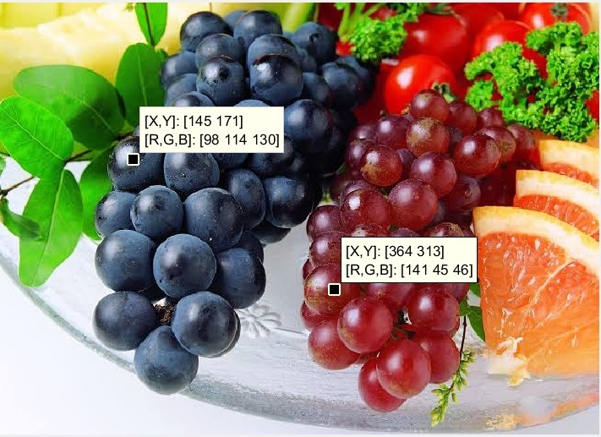

Enter the first pixel x coordiante 145
Enter the first pixel y coordiante 171
Enter the second pixel x coordiante 364
Enter the second pixel y coordiante 313

The value of Euclidean distance is
261.0077

The value of city block distance is
316

The value of Chess board distance is
171

Results

Thus the distances between two pixels were measured using MATLAB software.

EXP. 8
GRAY LEVEL TRANSFORMATION-IMAGE NEGATIVE

Aim:

To Perform image negative Gray level transformation function on image using MATLAB software

Apparatus Required

Personal Computer
MATLAB software

Program

A = imread('penguins.jpg');
subplot(2,2,1);
imshow(A);
title('Colour Image');
B = rgb2Gray(A);
subplot(2,2,2);
imshow(B);
title('Gray Scale Image');
C=255-B;
subplot(2,2,3);
imshow(C);
title('Image Negative');

Procedure

(i) Type the MATLAB coding in Script Page of program window
(ii) Save and Run the coding
(iii) Display, Save and Present the results for verification

Output
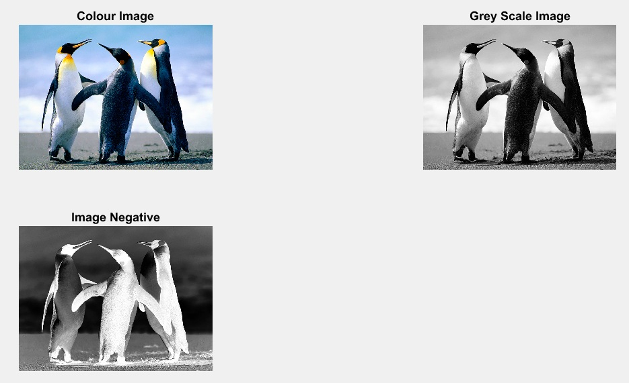

Results
Thus the image negative gray level transformation was performed on image using MATLAB software.

EXP. 9
BLURRING AND DEBLURRING

Aim:

To introduce blur in image and remove them using MATLAB software

Apparatus Required

Personal Computer
MATLAB software

Program

A = imread('penguins.jpg');
subplot(2,2,1);
imshow(A);
title('Input Image');
PSF=fspecial('gaussian',5,5);
B=imfilter(A,PSF,'symmetric','conv');
BPN=imnoise(B,'gaussian',0,0.002);
subplot(2,2,2);
imshow(BPN);
title('Blurred and Noisy Image');
% Deblurring
DB=deconvlucy(B,PSF,5);
subplot(2,2,3);
imshow(DB);
title('Deblurred Image');

Procedure

(i) Type the MATLAB coding in Script Page of program window
(ii) Save and Run the coding
(iii) Display, Save and Present the results for verification

Output
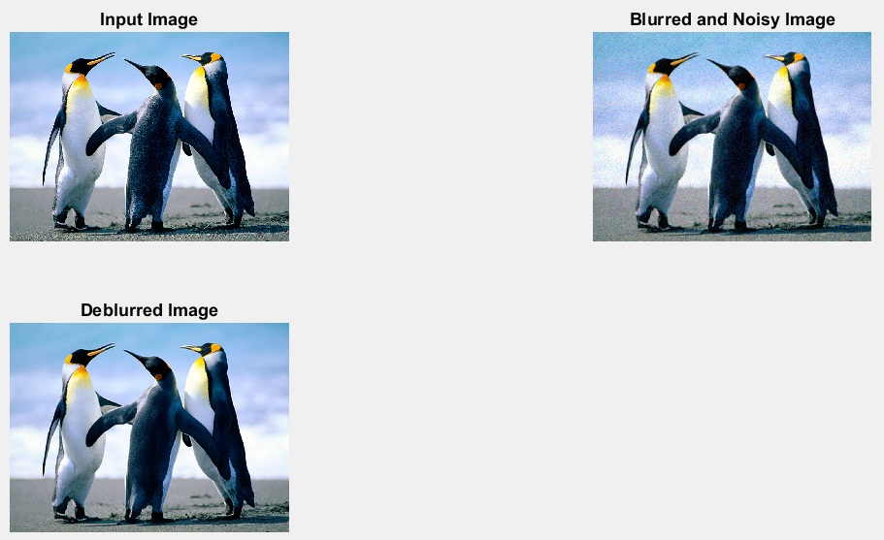

Results
Thus the blur in the image was removed using de blurring technique.

EXP. 10
HISTOGRAM EQUALISATION
Aim:

To implement histogram equalisation technique to Gray scale image using Matlab software.

Apparatus Required

Personal Computer
MATLAB software

Program

A = imread('desert.jpg');
I=rgb2Gray(A);
subplot(2,2,1)
imshow(I);
title('Gray scale image');
subplot(2,2,2)
imhist(I,64);
title('Histogram plot of Gray scale image');
J = histeq(I);
subplot(2,2,3)
imshow(J)
title('Contrast Enhanced image');
subplot(2,2,4)
imhist(J,64)
title('Histogram of contrast enhanced image')

Procedure

(i) Type the MATLAB coding in Script Page of program window
(ii) Save and Run the coding
(iii) Display, Save and Present the results for verification

Output

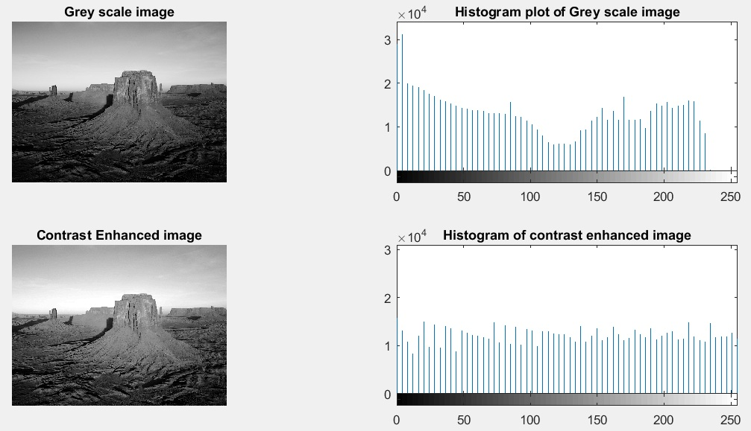

Results
Thus the Histogram equalisation was implemented for Gray scale images using Matlab software.

EXP. 11
NOISE FILTERING USING WIENER FILTER
Aim:

To remove noise from images using wiener filter.

Apparatus Required

Personal Computer
MATLAB software

Program

X = imread('butterfly.jpeg');
subplot(2,2,1);
imshow(X);
title('Input Image');
A=rgb2gray(X);
subplot(2,2,2);
imshow(A);
title('Converted Gray scale Image');
%Add Gaussian noise to the image
N = imnoise(A,'gaussian',0,0.025);
subplot(2,2,3);
imshow(N);
title('Image with Added Gaussian Noise');
K = wiener2(N,[5 5]);
subplot(2,2,4);
imshow(K);
title('Image with Noise Removed by Wiener Filter');

Procedure

(i) Type the MATLAB coding in Script Page of program window
(ii) Save and Run the coding
(iii) Display, Save and Present the results for verification

Output

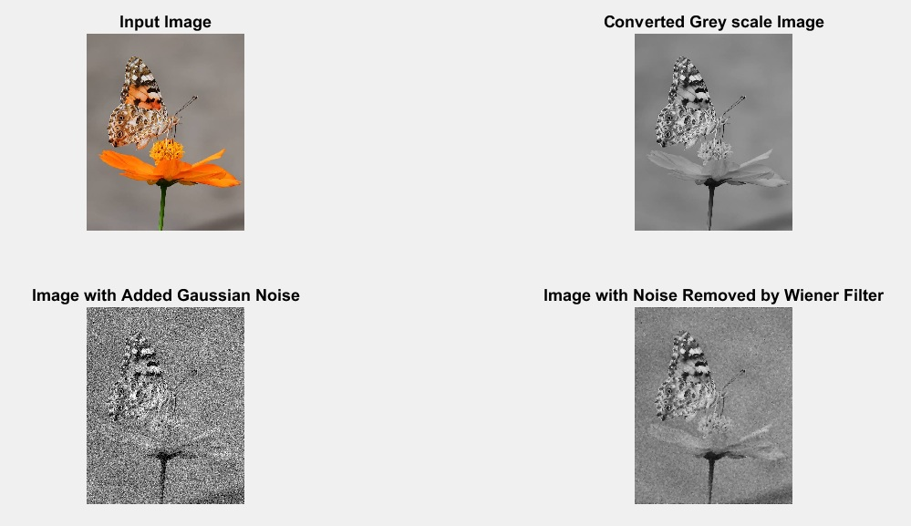

Results
Thus the Gaussian noise from image is removed using wiener filter

EXP. 12
NOISE FILTERING USING MEDIAN FILTER
Aim:

To remove noise from images using Median filter.

Apparatus Required

Personal Computer
MATLAB software

Program

X = imread('parrot.jpg');
subplot(2,2,1);
imshow(X);
title('Input Image');
A=rgb2gray(X);
subplot(2,2,2);
imshow(A);
title('Converted Gray scale Image');
%Add Gaussian noise to the image
N = imnoise(A,'gaussian',0,0.025);
subplot(2,2,3);
imshow(N);
title('Image with Added Gaussian Noise');
K = medfilt2(N,[7 7]);
subplot(2,2,4);
imshow(K);
title('Image with Noise Removed by Median Filter');

Procedure

(i) Type the MATLAB coding in Script Page of program window
(ii) Save and Run the coding
(iii) Display, Save and Present the results for verification

Output

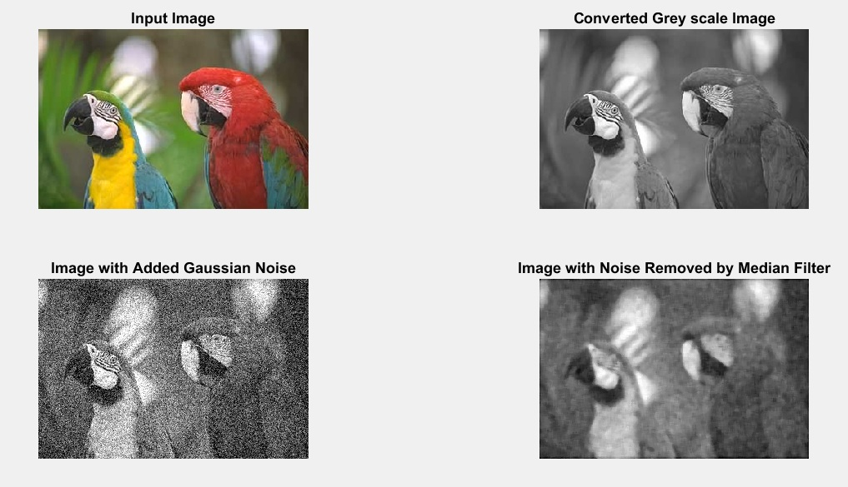

Results
Thus the Gaussian noise from image is removed using Median filter

EXP. 13
WAVELET SUBBAND CODING
Aim:

To implement wavelet sub band coding in images using MATLAB software.

Apparatus Required

Personal Computer
MATLAB software

Program
Y=imread('lena.png');
X=Y(1:512,1:512);
figure;
imshow(uint8(X));
[a1,a2]=size(X);
disp('The number of rows in input image are');
disp(a1);
disp('The number of coloums in input image are');
disp(a2);
figure;
title('Input image');
% Perform single-level decomposition
[cA1,cH1,cV1,cD1] = dwt2(X,'haar');
% Images coding.
[C,S] = wavedec2(X,1,'haar');
A1 = wrcoef2('a',C,S,'haar',1);
H1 = wrcoef2('h',C,S,'haar',1);
V1 = wrcoef2('v',C,S,'haar',1);
D1 = wrcoef2('d',C,S,'haar',1);
%Display the results of a first level decomposition.
colormap(gray);
subplot(2,2,1); image(wcodemat(A1,192));
title('Approximation A1')
subplot(2,2,2); image(wcodemat(H1,192));
title('Horizontal Detail H1')
subplot(2,2,3); image(wcodemat(V1,192));
title('Vertical Detail V1')
subplot(2,2,4); image(wcodemat(D1,192));
title('Diagonal Detail D1')
%Multi-level 1-D wavelet reconstruction.
re_ima1 = idwt2(cA1,cH1,cV1,cD1,'haar');
re_ima=uint8(re_ima1);
figure;
subplot(2,1,1);
imshow(uint8(X));
title('Input image');
subplot(2,1,2);
imshow(re_ima);
title('1-level reconstructed image');
figure;
%To perform a level 2 decomposition of the image
[C,S] = wavedec2(X,2,'haar');
% decomposse the image X in Level 2
%image coding
A2 = wrcoef2('a',C,S,'haar',2);
A1 = wrcoef2('a',C,S,'haar',1);
H1 = wrcoef2('h',C,S,'haar',1);
V1 = wrcoef2('v',C,S,'haar',1);
D1 = wrcoef2('d',C,S,'haar',1);
H2 = wrcoef2('h',C,S,'haar',2);
V2 = wrcoef2('v',C,S,'haar',2);
D2 = wrcoef2('d',C,S,'haar',2);
colormap(gray);
subplot(2,4,1);image(wcodemat(A1,192));
title('Approximation A1')
subplot(2,4,2);image(wcodemat(H1,192));
title('Horizontal Detail H1')
subplot(2,4,3);image(wcodemat(V1,192));
title('Vertical Detail V1')
subplot(2,4,4);image(wcodemat(D1,192));
title('Diagonal Detail D1')
subplot(2,4,5);image(wcodemat(A2,192));
title('Approximation A2')
subplot(2,4,6);image(wcodemat(H2,192));
title('Horizontal Detail H2')
subplot(2,4,7);image(wcodemat(V2,192));
title('Vertical Detail V2')
subplot(2,4,8);image(wcodemat(D2,192));
title('Diagonal Detail D2')
dec2d = [A2,A1,H1,V1,D1,H2,V2,D2];
%Multi-level 2-D wavelet reconstruction.
re_ima1 = waverec2(C,S,'haar');
re_ima=uint8(re_ima1);
figure;
subplot(2,1,1);
imshow(uint8(X));
title('Input image');
subplot(2,1,2);
imshow(re_ima);
title('2-level reconstructed image');

Procedure

(i) Type the MATLAB coding in Script Page of program window
(ii) Save and Run the coding
(iii) Display, Save and Present the results for verification

Output
FIRST LEVEL DECOMPOSITION
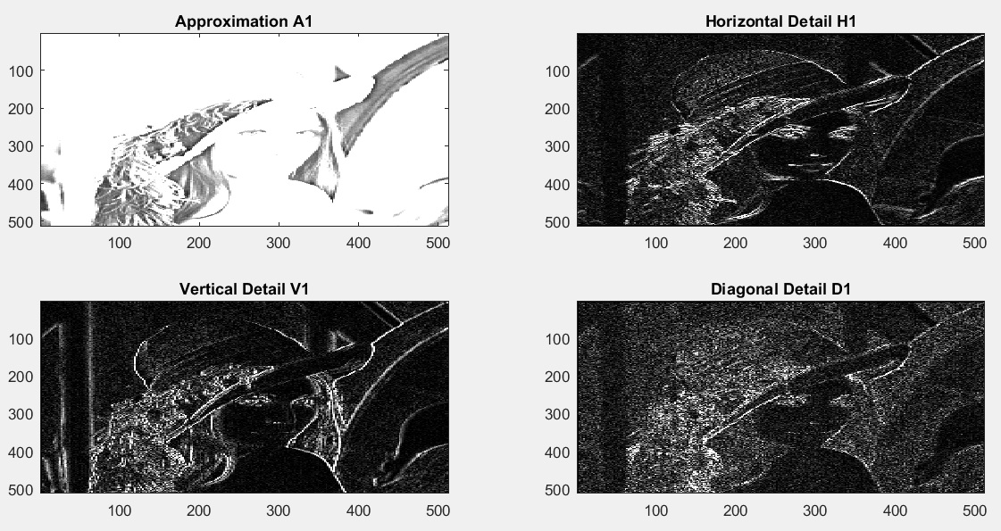

FIRST LEVEL RECONSTRUCTION
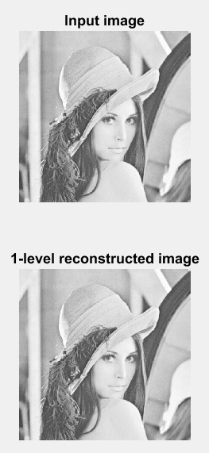
SECOND LEVEL DECOMPOSITION

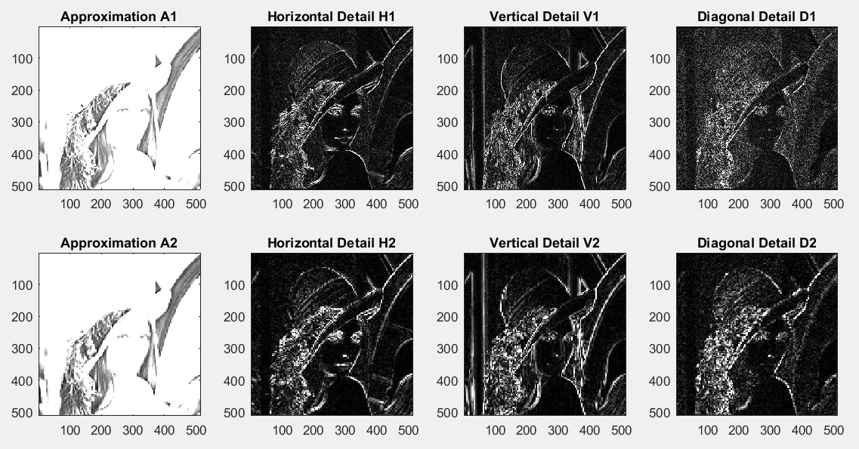

SECOND LEVEL RECONSTRUCTION

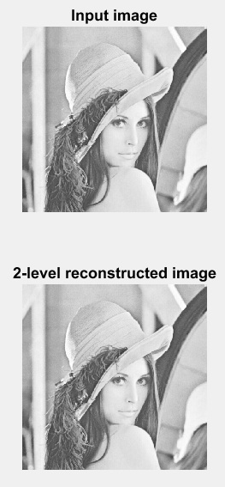
Result
Thus the wavelet sub band coding is implemented in images using MATLAB software

EXP. 14
IMAGE SMOOTHENING
Aim:

To perform image smoothening in images using MATLAB software

Apparatus Required

Personal Computer
MATLAB software

Program

im=imread('car2.jpg');
im1=rgb2gray(im);
im1=medfilt2(im1,[3 3]); %Median filtering the image to remove noise%
BW = edge(im1,'sobel'); %finding edges
[imx,imy]=size(BW);
msk=[0 0 0 0 0;
0 1 1 1 0;
0 1 1 1 0;
0 1 1 1 0;
0 0 0 0 0;];
B=conv2(double(BW),double(msk));
subplot(2,2,1);
imshow(im);
title('Input Image');
subplot(2,2,2);
imshow(im1);
title('Filtered Image');
subplot(2,2,3);
imshow(B);
title('smooth Image');

Procedure

(i) Type the MATLAB coding in Script Page of program window
(ii) Save and Run the coding
(iii) Display, Save and Present the results for verification

Output

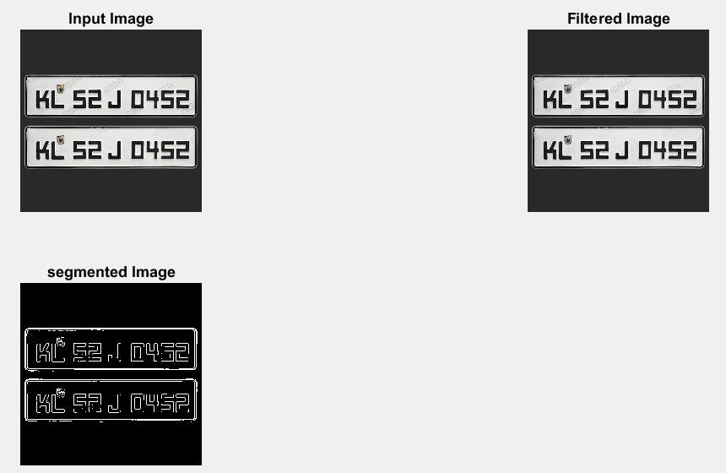

Results
Thus the image smoothening operation was performed on images using MATLAB software.

EXP. 15
MORPHOLOGICAL PROCESSING
(DILATION AND EROSION)
Aim:

To implement morphological image processing such as dilation and erosion in images using MATLAB software

Apparatus Required

Personal Computer
MATLAB software

Program

X = imread('xray.jpg');
subplot(2,2,1);
imshow(X);
title('Input Image');
A=rgb2gray(X);
subplot(2,2,2);
imshow(A);
title('Converted Gray scale Image');
SE = strel('ball',5,5);
B = imdilate(A,SE);
subplot(2,2,3);
imshow(B);
title('Dilated Image');
C = imerode(A,SE);
subplot(2,2,4);
imshow(C);
title('Eroded Image');

Procedure

(i) Type the MATLAB coding in Script Page of program window
(ii) Save and Run the coding
(iii) Display, Save and Present the results for verification

Output

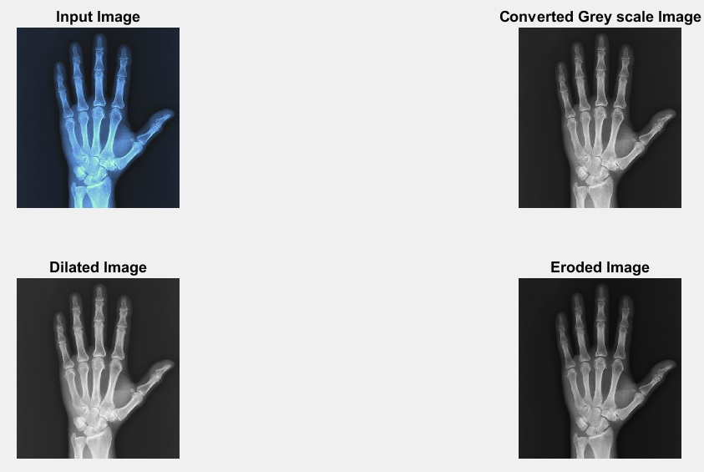

Results
Thus the morphological image processing such as dilation and erosion in images were implemented using MATLAB software.

EXP. 16
MORPHOLOGICAL PROCESSING
(OPENING AND CLOSING)
Aim:

To implement morphological image processing such as opening and closing in images using MATLAB software.

Apparatus Required

Personal Computer
MATLAB software

Program

X = imread('flower.jpg');
subplot(2,2,1);
imshow(X);
title('Input Image');
A=rgb2gray(X);
subplot(2,2,2);
imshow(A);
title('Converted Gray scale Image');
SE = strel('disk',5);
B = imopen(A,SE);
subplot(2,2,3);
imshow(B);
title('Opening in Image');
C = imclose(A,SE);
subplot(2,2,4);
imshow(C);
title('Closing in Image');

Procedure

(i) Type the MATLAB coding in Script Page of program window
(ii) Save and Run the coding
(iii) Display, Save and Present the results for verification

Output

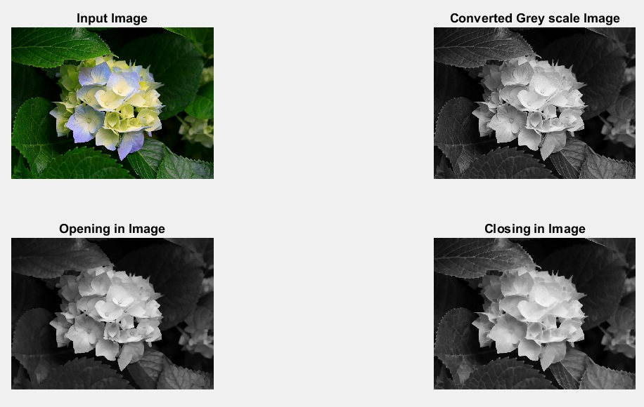

Results
Thus the morphological image processing such as opening and closing in images were implemented using MATLAB software.

Neighbour of 4,8 and Diagonal point
% To find Neighbour of a given Pixel
a=magic(5);
disp(‘a=’); disp(a);
b=input('Enter the row < size of the Matrix');
c=input(' Enter the Column < size of matrix');
disp(‘Element’); disp(a(b,c));
% 4 Point Neighbour
N4=[a(b+1,c), a(b-1,c), a(b,c+1), a(b,c-1)];
disp(‘N4=’); disp(N4);
%8 Point Neighbour
N8=[a(b+1,c), a(b-1,c), a(b,c+1), a(b,c-1), a(b+1,c+1), a(b+1,c-1), a(b-1,c-1), a(b-1,c+1)];
disp(‘N8=’); disp(N8);
%Diagonal Neighbour
ND=[ a(b+1,c+1), a(b+1,c-1), a(b-1,c-1), a(b-1,c+1)];
disp(‘ND=’); disp(ND);

Output
a=
17 24 1 8 15
23 5 7 14 16
4 6 13 20 22
10 12 19 21 3
11 18 25 2 9
Enter the row < size of the Matrix 3
Enter the Column < size of matrix 3
Element =
13
N4=
19 7 20 6
N8=
19 7 20 6 21 12 5 14
ND=
21 12 5 14

%Display the color image and its Resized images by different methods
%Display the color image
I=imread('embryo.jpg');
figure,
subplot(2,2,1);
subimage(I);
title('Original Image');
%Display Resized image by Bilinear method
B=imresize(I,5);
subplot(2,2,2);
subimage(B);
title('Bilinear Image');
%Display Resized image by Nearest method
C=imresize(I,5,'nearest');
subplot(2,2,3);
subimage(C);
title('Nearest Image');
%Display Resized image by Bicubic method
D=imresize(I,5,'Bicubic');
subplot(2,2,4);
subimage(D);
title('Bicubic Image');

Display of FFT(1-D & 2-D) of an image
l=im2double(imread('cancercell.jpg'));
f1=fft(l);
f2=fftshift(f1);
subplot(2,2,1); imshow(abs(f1)); title('Frequency Spectrum');
subplot(2,2,2); imshow(abs(f2)); title('Centered Spectrum');
f3=log(1+abs(f2));
subplot(2,2,3); imshow(f3); title('log(1+abs(f2))');
l=fft2(f1);
l1=real(l);
subplot(2,2,4); imshow(l1);title(' 2-D FFT');

Implementation of Image Intensity slicing technique for image enhancement
i=imread('earcell.jpg');
subplot(3,2,1);imshow(i); title(‘Original Image’);
l=im2double(i);
level=graythresh(l);
BW = im2bw(l,level);
subplot(3,2,2); imshow(BW); title('Image graythresh');
level1=0.2*BW;
subplot(3,2,3); imshow(level1); title('0.2 Slice');
level2=0.4*BW;
subplot(3,2,4); imshow(level2);title('0.4 Slice');
level3=0.6*BW;
subplot(3,2,5); imshow(level3);title('0.6 Slice');
level4=0.8*BW;
subplot(3,2,6); imshow(level4); title('0.8 Slice');

